FS 500031
* Robes, Rotterdam
A - NetSet-A (sandd.) 20g A 1117 c

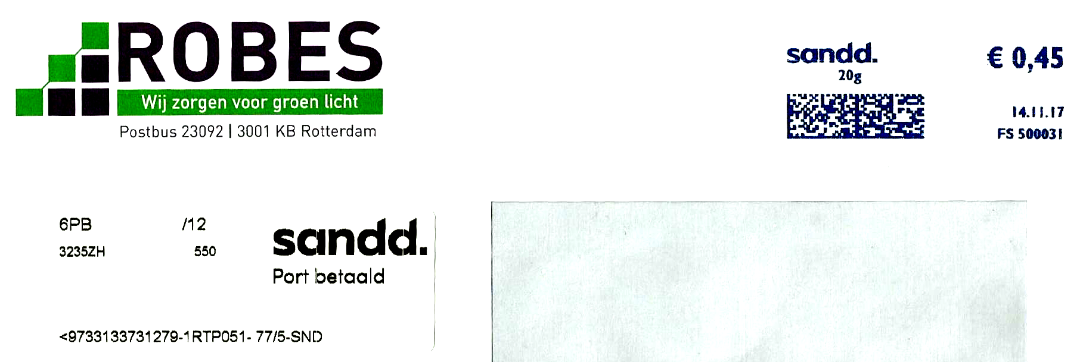

SD 000006
* Wabco, Capelle a.d. IJssel
A - NetSet-A (sandd.) 20g
1 WABCO A 1218 c

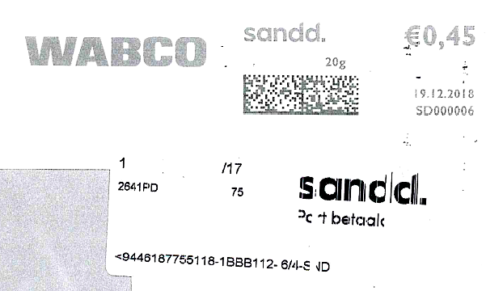

SD 000037
* Nivo Groep Zaandam B.V., Wormer
A - NetSet-A (sandd.) 250g A 0919 c

